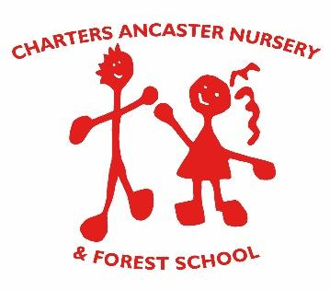

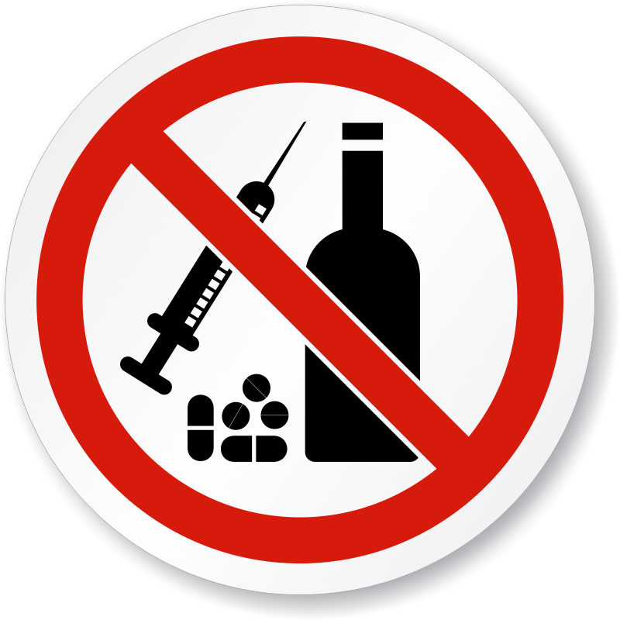

ALCOHOL, DRUGS
AND MEDICATION POLICY

Reviewed on | Approved by
06.05.2021 | N. Crump

Introduction
This policy informs practice in the Nursery. See also the “No Smoking and Vaping Policy”

- Charters Ancaster Nursery strongly prohibits staff from the use or possession of alcohol, illegal drugs, or illegal substances in our setting for their own use at any time. *

- If staff, students, or volunteers are found to have broken the rules in respect of this policy, it will be treated as a very serious disciplinary matter.

- All staff will be made aware of the provisions of this policy during their induction, including the importance of them setting a positive example to children.
Alcohol, Drugs & Illegal Substances
- Staff, students, or volunteers who arrive on the premises clearly under the influence of alcohol, illegal drugs or illegal substances will be asked to leave immediately and the appropriate disciplinary procedures implemented.

- If a member of staff has good reason to suspect that a parent/carer is under the influence of alcohol or illegal drugs when they drop off or collect their child, to the extent that the safety of the child is threatened, they have a duty to inform the Designated Safeguarding Leaders (DSL) In such circumstances, the DSL will then be responsible for deciding upon the appropriate course of action, ensuring that the safety and protection of the child remains paramount at all times. The DSLs for the Nursery are Nursery Manager Louise Pope and the Deputy Manager Claire Lee.

- Staff will make all possible efforts to ensure that children are not allowed to travel in a vehicle driven by someone who is clearly over the legal alcohol limit or who is clearly under the influence of illegal drugs. Where an illegal act is suspected to have taken place, the police will be informed.
Staff Medication
When staff are on medication that they need to bring to Nursery with them it must be kept in the lockable cupboard in the office especially for this purpose.

For child medication needed at Nursery, please see the “First Aid and Administration of Medicines Policy.”

*NB On the occasion of the Nursery Fairs, which are held at the weekend, bottles of alcohol may be brought into school by parents for the bottle stall and at the Summer Fair alcohol may be sold to adults for social reasons, providing an events licence has been obtained. If social events are held in the evening alcohol may be brought to be consumed by adults. However on these occasions the adults present will be reminded to not drink and drive.

