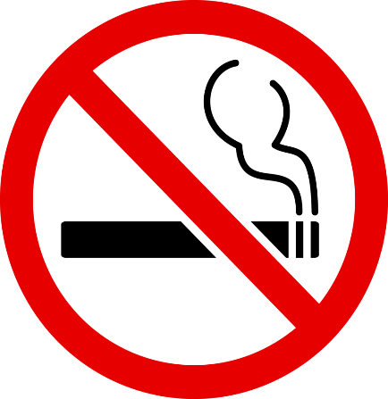

NO SMOKING AND NO VAPING POLICY

Reviewed on | Approved by
06.05.2021 | N. Crump

- Introduction

  - The Nursery, under the Health and Safety at Work Act (1974), has a duty of care to provide a healthy work environment. Nurseries have a major role to play in health education and prevention.

  - Young children need to receive consistent messages and require non-smoking role models within the Nursery. It has been shown that the biggest factor affecting youth smoking is prevalence of adult smoking and children’s exposure to seeing smoking (ASH, 2004).

  - The Nursery acknowledges that second-hand/ Third hand tobacco smoke and fragrance is both a public and work place health hazard and has therefore adopted this Smoke Free Policy.

  - https://breatheeasymaine.org/facts/tobacco/secondhand-and-thirdhand-smoke/ - For more information please visit this website regarding second and third hand smoke.

- Aims of the Policy
  - The policy seeks to:
- Guarantee a healthy working environment and protect the current and future health of children, employees, and visitors.
- Guarantee the right of non-smokers to breathe in air free from tobacco smoke.
- To comply with Health & Safety Legislation and Employment Law.
- Raise awareness of the dangers associated with exposure to tobacco smoke.
- Take account of the needs of those who smoke and to support those who wish to stop.
- Restrictions on Smoking
  - Smoking or vaping is not permitted in any part of the premises, including grounds.

  - The policy applies to employees, parents, visitors, members of the public, contractors and others working or using the Nursery premises or sitting in vehicles in the car park. This policy will be clearly advertised and visitors to the school will be informed of it.

  - This policy will apply to all activities held in the school, including before and after school sessions and any meetings organised which are attended by employees as part of their work, and/or visitors to such meeting/events.

  - This policy will apply to off-site activities.

  - Employees should avoid being seen smoking or vaping in public in sight of children, parents and visitors in order to reinforce a comprehensive approach.

  - Employees are required to refrain from smoking/vaping while on the nursery site, even in their dinner hour because their clothes/hair will smell of smoke. This rule applies also if off the premises during breaks.
- Vehicles
  - Employees are asked to refrain from smoking or vaping in their own vehicles whilst on duty or when used on school business and when carrying passengers.
- Disciplinary Action
  - The enforcement of the No Smoking and No Vaping policy will be the responsibility of the Nursery Manager.The Nursery's disciplinary procedure will apply when dealing with breaches to this policy. Anyone raising genuine concerns about breaches of the policy will be protected from victimisation.

  - Staff are authorised to ask non-employees who breach the policy to leave the premises.
- Support for Smokers
  - All local doctors' surgeries offer a stop smoking service on a one-to-one basis, usually with a Practice Nurse with support over the first few weeks of quitting, along with a prescription for products that can help with cravings.

  - If smokers want to access this service they should contact their doctor's surgery and ask to make an appointment about stopping smoking.

  - NHS Smokefree Helpline: 0800 0224 332. This offers friendly, free help and support. It can also put the smoker in touch with the Stop Smoking Service in their area.

