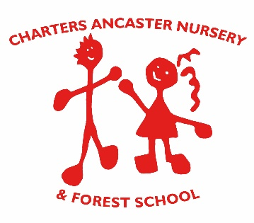

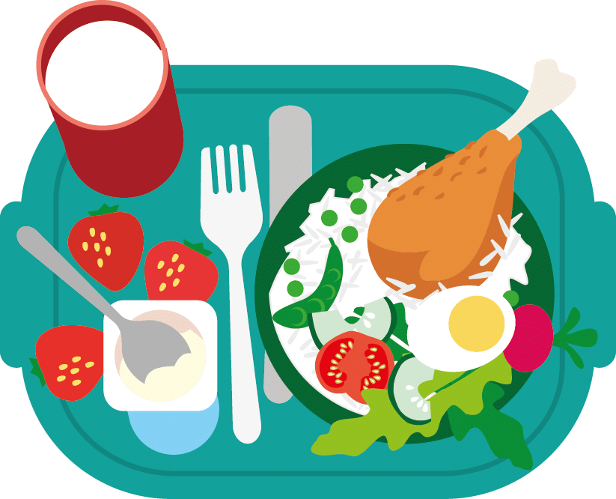

HEALTHY FOOD AND DRINK,
& FOOD SAFETY POLICY

Reviewed on | Approved by
06.05.2021 | N. Crump

Charters Ancaster Nursery and Forest School follows the
Early Years Code of Practice for Healthy Food and Drink.
Aims
We have a Healthy Food and Drink Policy to meet the following principles:
- We have the H.F.&D. Policy in place to outline our approach to all aspects of food and nutrition.
This means that everyone involved with our setting knows what foods are on offer to children here, when and where they eat, and how we use food to support children’s learning.

- We consult families and children and keep them informed about issues relating to food and drink.
This means that we talk to families about issues such as timing of our meals and snacks, the types of food and drink we provide, and what their children eat. We encourage families to give us their views.

- We plan varied menus for meals and snacks in advance, which include different tastes, colours, and textures of food and take into consideration seasonality, sustainability, and impact on the environment where possible. This means that staff with appropriate skills plan menus so that all the children we look after are offered varied and balanced food and drink.

- We provide meals and snacks that are planned so that they meet the national best practice food and drink guidelines.ie National voluntary food and drink guidelines for Early Years settings. Eg protein, fruit/veg and carbohydrate given at snack time. Milky puddings given at lunch., Whole milk used for under twos. Etc

- We cater for the dietary requirements of all children wherever possible. We work with families to make sure that any special dietary requirements (including food allergies and intolerances) are accommodated and that children of all cultures and religions can enjoy appropriate meals and snacks.

- We have a positive and welcoming eating environment, to encourage children to eat well, and develop good eating habits and social skills. We use the whole day, as well as meals and snacks, to teach children about healthy eating and encourage a positive attitude towards mealtimes.

- We encourage independence skills by enabling children to access snacks. make choices and tidy away themselves with greater freedom but with support as they progress through the classes.

- We have had training to make sure that we are able to provide children with appropriate food and drink for their needs and are effective role models. This means that staff planning and preparing meals in this setting have had relevant training in food hygiene and that staff talk to children about food in a knowledgeable and enthusiastic way.
FOOD SAFETY
Charters Ancaster Nursery and Forest School complies with the Food Standards Act 1999 and Food Safety (General Food Hygiene) Regulations 1995.
The Food Safety Act 1990 covers all aspects of food preparation/production and service which offer food for human consumption- whether carried out for profit or not. The Act includes food and drink given away as a prize or a reward in any way. Fines for non-compliance are severe.
This policy adopts the Food Safety Educational Establishments Code of Practice No 10-June 1998. Included in this is the Food Safety Best Practice, copies of this will be displayed/distributed to relevant staff and school & nursery users.
TRAINING STAFF
- It is the responsibility of the Management to ensure that a member of Kitchen staff in the Nursery holds a valid Basic Hygiene Certificate.

- The Nursery will ensure that a member of staff responsible for Food Safety cascades appropriate information for staff training to those applicable
STORAGE OF FOOD
Fridge temperatures
Fridges used for the storage of food should be checked each day to ensure that the temperature in the fridge falls under 5+degrees centigrade and in the freezer stays below -18degrees Centigrade this is because those temperatures prohibit the growth of unhealthy bacteria.
The fridge should be defrosted regularly to maintain good storage conditions.
FOOD IN A LEARNING CONTEXT
Curriculum Activities
Staff will often use food as a development of a particular topic, as well as teaching children about healthy and unhealthy food. Such a topic might be ‘Where our food comes from’ or ‘On the farm’, when they might grow vegetables and sample them, or in a topic about Festivals may learn about the foods of other cultures as well as their own.
Cooking will play a role in nursery activities and be used as another way of teaching children about food and its benefits to them, such as keeping them healthy, giving them energy and caring for their teeth etc This will be included principally as part of the Physical Development and Understanding the World curriculum.
NB Prior to any food tasting sessions, a letter of consent must be signed by parents/carers.

DIETARY REQUIREMENTS
Allergies * Please see Allergy policy
We are a nut-free nursery to avoid any danger associated with nut allergies. We also do not allow grapes as they can be a choking hazard.
We keep a list of children’s medical needs including allergies and intolerances and staff are aware of children’s requirements. The cook can cater for any allergies and intolerances to ingredients such as dairy, eggs, etc but the parent/carer should provide medical evidence if their child needs a special diet.
Some children have a recognised medical difficulty in eating any but particular foods and the staff will work with parents and medical staff to help children eat healthily.
We like to encourage the children to try a wide variety of foods.
Staff update ‘Famly’ after every meal to keep parents informed on what their children have eaten during the day at Nursery.
FOODS AND DRINKS AVAILABLE
- Water is always available for children to drink. Many children bring their own water bottles. Milk is served at snack time.
- We have a policy of NO juice in water bottles.

WHO PLANS THE MENUS?
- A varied diet of healthy food and snacks on a rotating four weekly plan is provided. Our qualified cook plans these meals in accordance with healthy food guidelines for children. Parents can request a copy of these menus. (See Appendices 1,2 for Guidelines for Healthy snacks and Hygiene criteria)
WHEN DO CHILDREN HAVE MEALS AND SNACKS?
8.00 - 8.30am Breakfast if booked during early waiting
10.30 -11.00am Mid-morning Snack
12.00-12.30am Lunchtime
2..00-2.30am Afternoon Snack
5.00am Tea
(N.B. These are approximate times as classes vary their routine and may have a ‘rolling snack’.)
WHERE DO CHILDREN EAT?
The youngest children eat in their classrooms around tables or on low-chairs.
The snacks are all prepared by staff following hygienic guidelines to clean surfaces in eating and serving areas. The lunch time food is transported from the kitchen in heated containers to the Chalet.
The Twiglets. Chestnuts and Sycamores eat their lunch in a Dining Room in the Main House at small tables. They are encouraged to eat their meals in a convivial and educational way through using cutlery and table manners and engaging in conversation with friends on their table.
They are encouraged to be independent by clearing and stacking their plates and placing cutlery for washing. They eat their snacks in the dining room or classroom and even outside if weather permits.
They always wash their hands before eating food or if water is not available hygienic wipes are used to clean hands.
BIRTHDAYS AND TREATS
Parents may provide their child with a birthday cake. However, the cake will not be eaten at nursery but given to children to take home so each child’s parents can decide whether their child should eat it or not. Sweets are also sent home if given as treats or prizes. The nursery has a policy of NOT using food as rewards.
PACKED LUNCHES
If preferred Children can bring in a home-prepared packed lunch to nursery to eat beside those children who have cooked lunches. Parents are asked to abide by the Healthy Food and Drink policy and provide their child with a healthy lunch.
FOREST SCHOOL
Food at Forest School is prepared according to these guidelines. Very occasionally the children may have warm drinking chocolate, or marshmallows as part of an activity.
Refer to the Forest School Eating policy for other information.
STAFF FOOD
Any food brought into the nursery by staff for their own consumption is not the responsibility of the nursery. The equipment provided ie fridge, microwave and cooker etc are used at their own risk and compliance to Health and Safety regulations must be adhered to.

APPENDIX 1
RECOMMENDED GUIDELINES FOR HEALTHY SNACKS
Aims:
To establish sound eating habits for life through the provision of healthy snacks between meals that meet the nutritional requirement of a growing child.
To encourage good social eating practices in hygienic surroundings.
Objectives:
- Children will have the opportunity to try an increased variety of food and will have access to healthy snacks.

- Water will be available at all times.

- Staff will be with children while they eat and will provide a good role model for healthy eating.

- Children will be encouraged to develop good eating habits and will be given plenty of time to eat.

- Parents of children who are on special diets will be asked to provide as much information as possible about suitable foods.

- Non- food items will be used as a reward for children instead of confectionery.

- Healthy food options will be used in all activities, whenever possible: in play, in education, language, cooking and other events.

Advisory Panel for Health and Food in the Early Years -Ticknell 2011

APPENDIX 2
HYGIENE CRITERIA FOR SNACKS
Do you prepare high-risk foods eg cooked food, sandwiches with fillings? NO
- If answered No the following criteria have to be met.
- Does the fridge have a thermometer to measure temperatures? Yes
- Are you buying food from a reputable supplier? Yes
- Is all decanted food labelled with a ‘use by’ date? Yes
- Is the food preparation area clean and in good repair and condition? Yes
- Is antibacterial cleaner available? Yes (This should be used prior to commencement of food preparation)
- Is hot and cold water available? Yes
- Is soap available, preferably liquid antibacterial soap available in a dispenser? Yes
- Do staff wash their hands with soap and water before the consumption of snacks? Yes
- Is there a NO smoking and vaping policy in operation? Yes
- Is the general condition of the building suitable for food preparation? Yes

