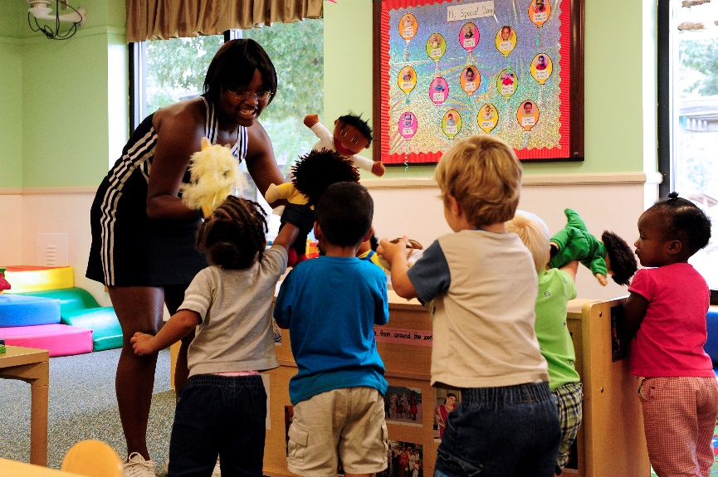

SUPERVISION OF CHILDREN POLICY

Reviewed on | Approved by
06.05.2021 | N. Crump

INTRODUCTION
This policy informs practice in the Nursery.

LEGAL OBLIGATIONS AND DUTY OF CARE

All staff are under a legal duty to exercise ‘reasonable care’ to see that all pupils are kept safe. We recognize that on occasions, accidents will happen. However, the Supervisions Policy seeks to ensure that staff are enabled to consider their position and recognize their supervision responsibilities. Children are never to be left unattended in the Nursery. Charters Ancaster Nursery seeks to employ staff in numbers at least required by law but often better than the expected ratio of staff to children.

The Nursery Manager is required to ensure that the Nursery is a safe place of work for employees and for others who enter the Nursery. The Practitioners have a duty of care to the children, which is based on the principle of loco parentis.

- Regard is given to the ages and capabilities of all pupils and there is an understanding that whilst independence is encouraged, the Nursery children are still very young and will require constant supervision.
- Risk assessments are made and kept updated as necessary for both on site and off- site activities.
- Nursery rules seek to eliminate (or significantly reduce) anticipated risks, and these rules are known to the children at their age level. These are regularly revisited.
- All staff are aware of their supervisory responsibilities, a breach of which would be considered very serious.
- Where there has been an accident/incident which had not been foreseen, the risk of a repetition is considered and risk assessments are made. Parents are to be informed should this happen and the appropriate paperwork completed by the Nursery Manager.

NEGLIGENCE
If a claim for negligence is brought against the Nursery it is important to show that adequate supervision plans exist. High standards of supervision must be maintained at all times by staff. These will be within or better than ratios set by the government.

Charters Ancaster Nursery has the following measures in place to safeguard its children:

- If a pupil has to be sent home unwell, they will not be allowed to leave the Nursery premises until their parent or guardian is aware of the situation. In the unlikely event of a child needing hospital treatment in an emergency, a member of staff will accompany the child until the parent or guardian arrives and assumes responsibility.

- If a child is too unwell to attend nursery, or cannot attend for any other reason, the Nursery must be informed by the parents or guardian by 10am at the latest in the morning and 2.00pm in the afternoon or the first day of absence. If the Nursery is notified of the absence of a child, this information is entered in the register and staff are informed. (See the Attendance policy)

- At all times, supervision by adults will be at least within EYFS ratios. (Ofsted)

- As part of the Nursery’s requirements to protect the children in its care, all visitors to Charters Ancaster Nursery are expected to sign in and out in the nursery. Regular practitioners wear sweatshirts with the nursery logo. All other adults should wear badges or lanyards identifying who they are.

- All staff should be prepared to challenge strangers on the premises, and to report concerns to the Office.

- At all times there will be at least ONE member of staff trained in Paediatric First Aid on site and this includes on trips out of Nursery.

SUPERVISION DURING THE NURSERY DAY.
- Staff supervision will always be within or better than the guidelines set by EYFS and Ofsted. Eg Under 2yrs - 1 adult:3 children, Under 3yrs - 1 adult :4 children, 3 to 5yrs - 1 adult to 8 children
(Unless the adult is a qualified teacher when ratio can be 1 adult; 13 children)

SUPERVISION IN THE ROOMS
- Classes must be supervised at all times and should never be left without an adult Nursery practitioner watching directly over them. Children should not be left with other adults except checked Nursery staff at any time.

SUPERVISION OUTSIDE THE CLASSROOM
- There are staff duty rotas for supervision during early waiting, lunch and through late waiting throughout the year. Punctuality and reliable attendance is of paramount importance.

SUPERVISION OF CHILDREN ON VISITS
- When children are taken from nursery on organized visits the same duty of care arises from being in loco parentis. It covers the duration of the whole visit and should include arrangements for the collection of the children at the end of the visit

